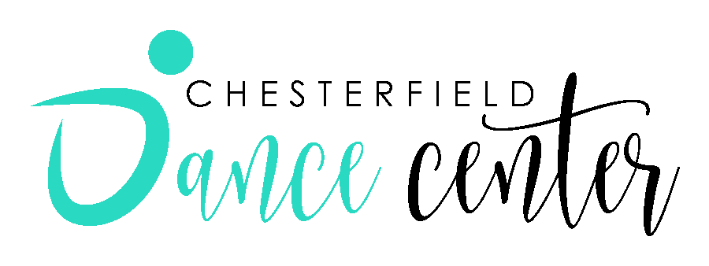
WAIVER CONCERNING NOVEL CORONAVIRUS/COVID-19
The Novel coronavirus, COVID-19, has been declared a worldwide pandemic by the World Health Organization. COVID-19 is extremely contagious and believed to be spread from person to person contact. As a result, federal, state, and local governments, and federal and state health agencies recommend social distancing and have, in many locations, prohibited the congregation of groups of people.
Chesterfield Dance Center, LLC has put in place preventable measures to reduce the spread of COVID-19; however, Chesterfield Dance Center, LLC cannot guarantee that you or your child(ren) will not become infected with COVID-19. Further, attending Chesterfield Dance Center, LLC could increase your risk and your child’s risk of contracting COVID-19.
By signing this agreement, I acknowledge the contagious nature of COVID-19 and voluntarily assume the risk that my child(ren) and I may be exposed to or infected by COVID-19 by attending Chesterfield Dance Center, LLC, and that such infection or infection may result in personal injury, illness, permanent disability and death. I understand that the risk of becoming exposed to or infected by COVID-19 at Chesterfield Dance Center, LLC may result in the actions, omissions, or negligence of myself, and others, including, but not limited to, Chesterfield Dance Center, LLC employees, volunteers, program participants, and their families.
I voluntarily agree to assume all of the foregoing risks and accept sole responsibility by any injury to my child(ren) or myself (including, but not limited to, personal injury, disability, and death, illness, damage, loss, claim, liability of expense, of any kind, that I or my child(ren) may experience or incur in connection with my child(ren)’s attendance at Chesterfield Dance Center, LLC or participation in any affiliated programs (“Claims”). On my behalf, and on behalf of my child(ren), I hereby release, covenant not to sue, discharge, and hold harmless Chesterfield Dance Center, LLC, its employees, agents, and representatives, of and from the Claims, including all liabilities, claims, actions, damages, costs or expenses of any kind arising out of or relating thereto. I understand and agree that this release includes any Claims based on the actions, omissions or negligence of Chesterfield Dance Center, LLC, its employees, agents, and representatives, whether a COVID-19 infection occurs before, during or after participation in any Chesterfield Dance Center, LLC program. Further, I agree to inform Chesterfield Dance Center, LLC if any infection or exposure should occur.
BY REGISTERING AND PAYING FOR ANY CLASS, EVENT, PRIVATE LESSON, OR OTHER ACTIVITY, YOU ARE AGREEING TO ALL OF THE ABOVE CONDITIONS AND WAIVERS. IF YOU ARE AN ATTENDEE OF OUR REGULAR CLASSES AND HAVE REGISTERED THROUGH THE PARENT PORTAL, YOU AGREED THROUGH THERE AS WELL. PLEASE DO NOT HAVE YOUR CHILD/YOURSELF PARTICIPATE IN ANY CLASS OR EVENT UNLESS YOU ACCEPT AND AGREE TO ALL OF THE TERMS IN THIS AGREEMENT.
PARENT NAME (PRINTED)________________________________________
PARENT SIGNATURE______________________________________ DATE__________________
DANCER’S NAME______________________________________

